VALİ SABAHATTİN ÇAKMAKOĞLU SECONDARY SCHOOLMERSİN/TURKEY
Values -Treasureand Challenge forEurope'sYouth
*Inviting people to school to hear about their visions of their later life they had as youngsters and if and how their visions have become reality.
Firstly I asked a 5th grade class pupils and their teacher to work on this activity with their parents all together.Some of the parents of that class joined in the activity.We had a meeting with those parents without pupils at first.They were asked to describe their visions of their later life and if and how their visions had become reality on a piece of paper.
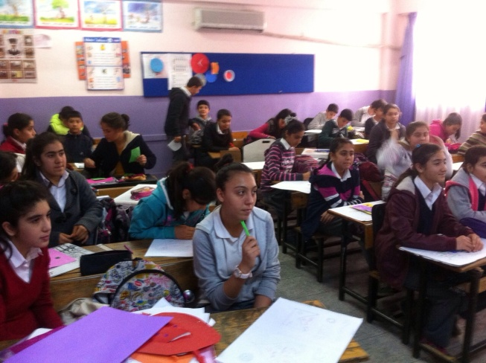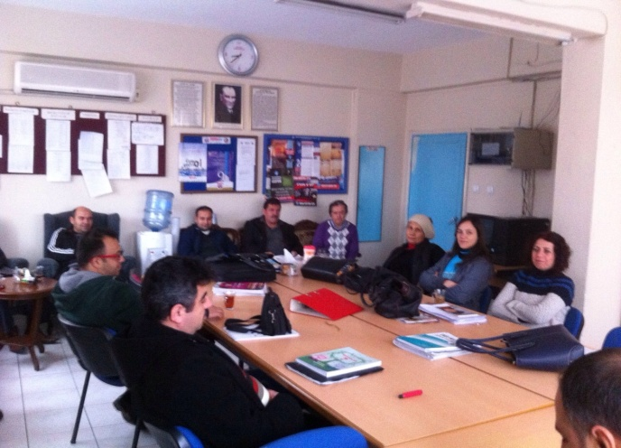
Later those that they had written were discussed all together with the parents.After that,they were asked to Express their writings to a few classes at school and they were invited to school one day for the pupils to hear about their visions.
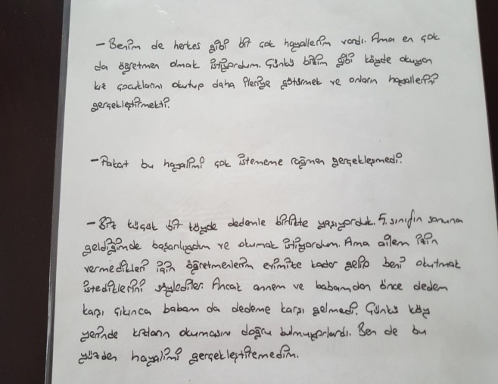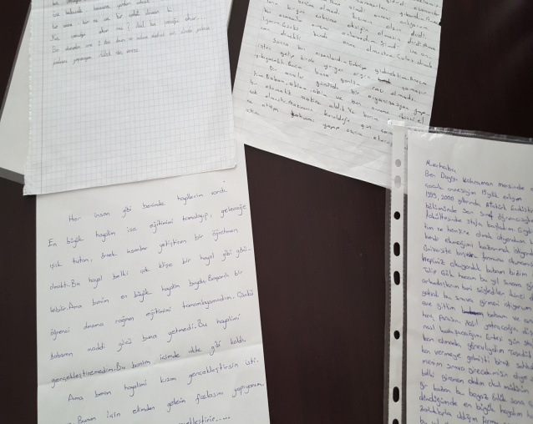

A meeting with a few parents was done to inform them about the activity. Their visions of their later life they had as youngsters and if and how their visions have become reality were discussed all together.

