VALİ SABAHATTİN ÇAKMAKOĞLU SECONDARY SCHOOLMERSİN/TURKEY
Values -Treasureand Challenge forEurope'sYouth
Visiting places outside school to practise persistence (eg.climbing forest or wall,longer hikes)
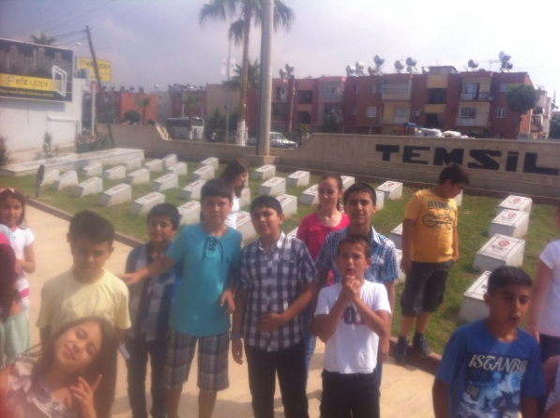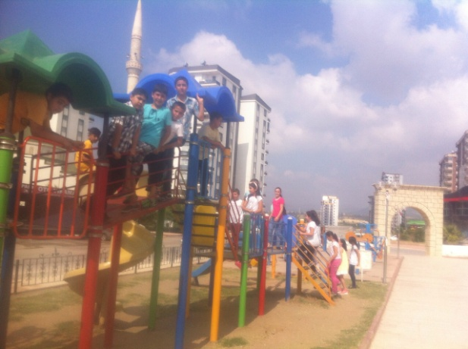
A longer hike to practise persistence was implemented with pupils.Firstly representation of martyrdom was visited.Then the had great time at playground.Later they went on hiking all together.On the way back to school some food were eaten.
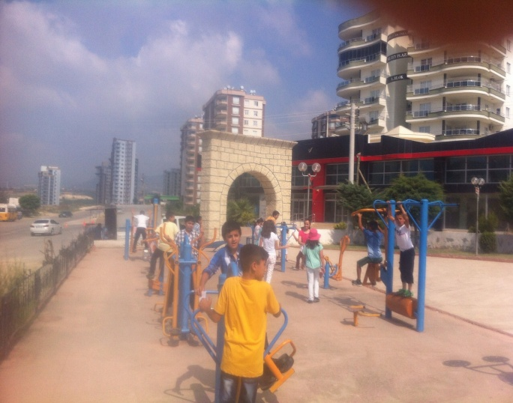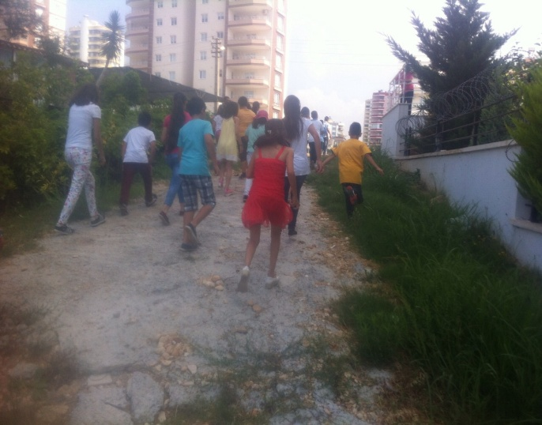

The pupils had a great time and enjoyed so much.They had noticed once more that doing sports was both enjoyable and useful.Thus the benefit and importance of doing sports lifelong was described to the pupils.

