VALİ SABAHATTİN ÇAKMAKOĞLU SECONDARY SCHOOLMERSİN/TURKEY
Values -Treasureand Challenge forEurope'sYouth
*Discussion regarding the achievement of self-set targets, discussing strategies for continuity to reach goals.. Design of motivation-memos for desk, mirror in the bathroom etc. that inspire not to give up. Exhibition of motivation-memos in school hall/corridor

The pupils were asked what they did in order to reach their goals.4 main questions were asked. The pupils were asked to answer the questions.The answers were evaluated and discussed.
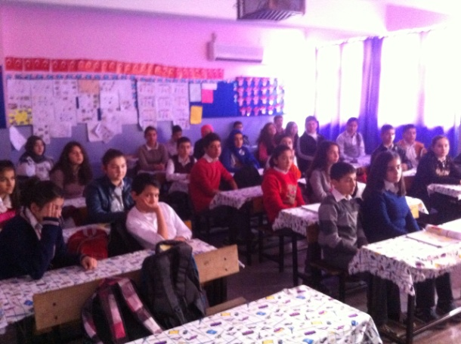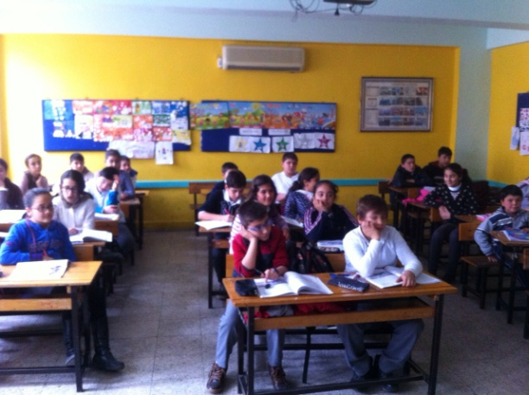
Cartoons,maxims and information papers were prepared.Besides those,the pupils were let known the information about the vocational high schools.Also a board was prepared about it.
