VALİ SABAHATTİN ÇAKMAKOĞLU SECONDARY SCHOOL MERSİN/TURKEY
Values-Treausureand Challenge forEurope’sYouth
A discussionabout“ How can I reachmygoals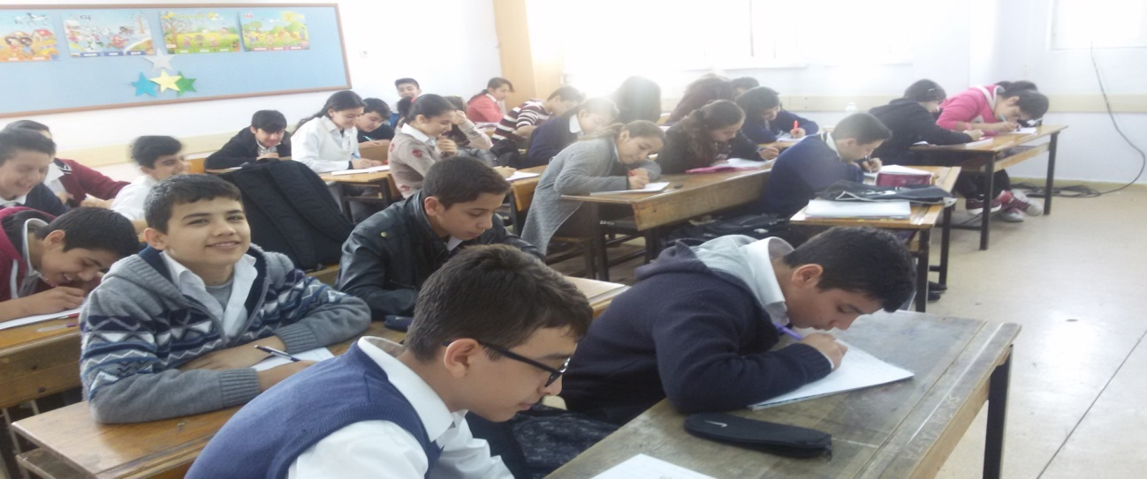Thestudentswereaskedtheirgoals.Theydescribedtheirgoals in theirletters.Most of thestudentsexpressedthattheywantedtogethighmarks in TEOG(Basic Training SecondaryEducationEnterance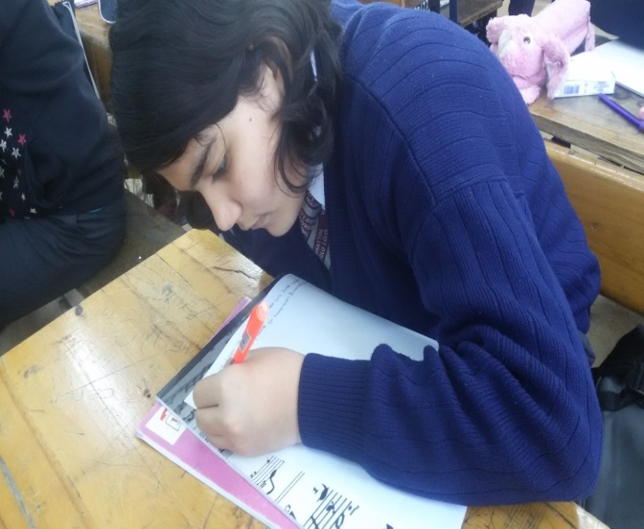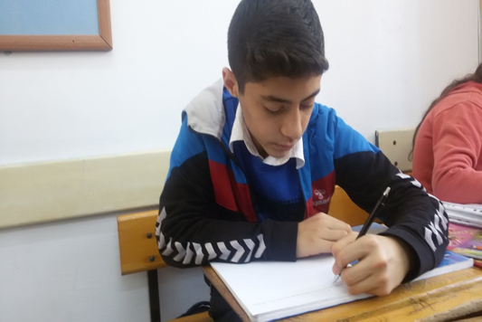
Exam)
Some of themwantedto be a gooddoctor,some a goodnurseandsome a good pilot.
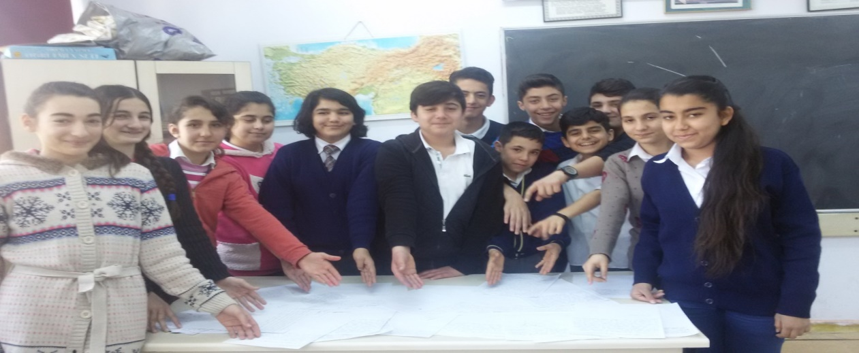
Thesubjectwasexplainedtothestudents in a detailedway.Theatmospherewasprepared fort themtoexpresstheirgoalsbetter.
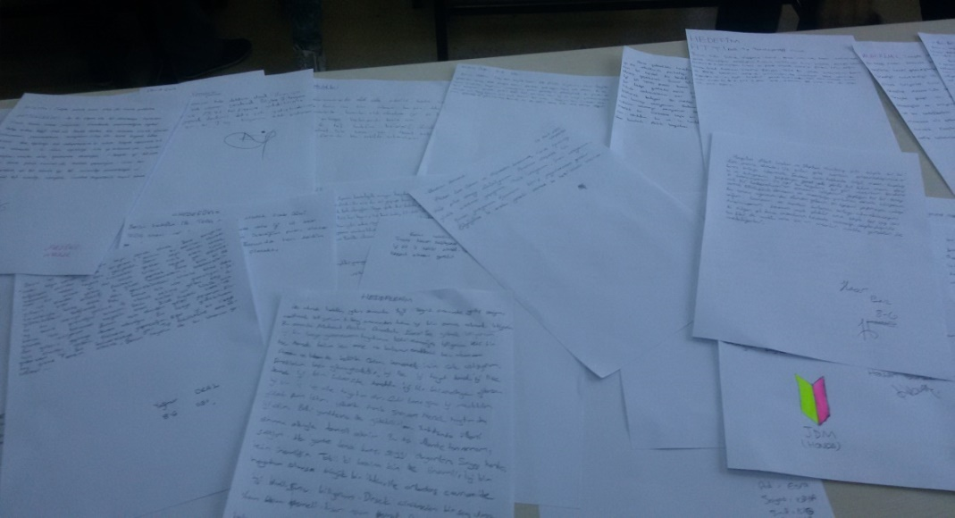

Thestudentsbecameveryhappy as theyexpressedandsharedtheirgoalswiththeirteacher.

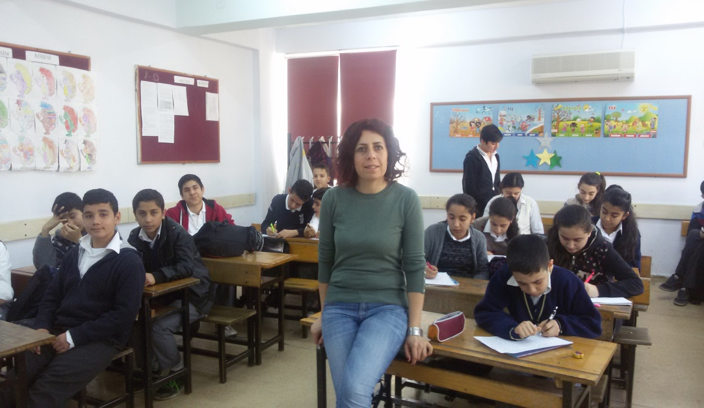

Most of thestudents’goalswerebeingsuccessul in theexam of TEOG(Basic TrainigSecondaryEducationEntaranceExam).That has shown how importancetheygavetotheexam.

