VALİ SABAHATTIN ÇAKMAKOĞLU SECONDARY SCHOOL
MERSİN/TURKEY
Values -Treasureand Challenge forEurope'sYouth
SHORT PLAYS(SKETCHES):
Pupils wrote short plays (sketches) that demonstrate the importance of the values and rules and practiced the plays and performed the plays to an audiance, taking a video of the performance to show it e.g. on open days.One of the examples of our sketches is that:
The sketch is in a bakery among a teacher,an old woman and a baker.The pupils acted it successfully.Also the performance is recorded.In this play solidarity is emphasızed.
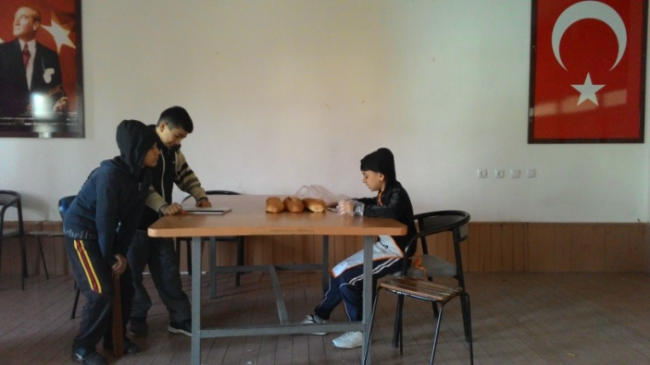
PASTRY:
Teacher:Hi!I can’t see any bread in the bakery.
Baker:Teacher,have a rest a few minutes.We are just removing.
Teacher:The hot weather in the bakery relaxed my body in such a cold winter day.And the bread smells very nice.
Old Woman:I’d like to buy the bread as usual.The twins are hungry.
Baker:I’m putting 3 stale and burnt bread.
Teacher:Why don’t you give her hot and fresh bread?
Baker:She wants those herself.Those are sold for a half price.
Teacher:It’s the first time I hear such a thing.Who is that old woman?
Baker:She lost her son and daughter-in law in an earthquake.She looks after her grandsons for a few years with a little salary.
Teacher:Today please give her the hot and fresh ones.I’ll pay the removing money.In this way they’ll eat fresh bread at once.
Baker:Then I’m putting those fresh ones.Heyy!!You are so lucky today.I’ll give you ones like pastry for your twins.
Old Woman:God bless you,sonny!!How did you know that its their birthday today?

